Awesome Study Tips and Websites for College Students
SIC TRIO FALL 2013

Spotlight Sites
Not sure how to figure out your GPA? Try out this interactive calculator. It's for the whole semester and it includes +/- letter grades. CALCULATE YOUR GPA-
http://www.back2college.com/gpa.htm

Syllabus = college vocabulary. Find out what it is in this short video. What's a Syllabus? Sheet.
http://www.upei.ca/media/video/y/2011/03/15/whats-a-syllabus

Tips for taking online courses
"Taking online classes is not necessarily the same as taking face to face courses. Get hints and tips here!" http://distance-ed.math.tamu.edu/tipsforonline.htm

10+ suggestions for studying with kids underfoot, from planning tasks for the kids to developing a routine, to playing with children during study breaks. Lots of specific tips here.
Studying with kids underfoot
http://www.lsus.edu/offices-and-services/student-development/student-support-services/tips-for-college-students/adult-learners/studying-with-kids-underfoot

Check out College Professors expectations vs. High School teachers How College Differs from High School http://www.baylor.edu/support_programs/index.php?id=88158

"Designing Effective Posters"
This classic model began at the University of Kansas Medical Center. It is still in use today. Here are the step by step directions. Poster Presentation and how to do it.
http://www.kumc.edu/SAH/OTEd/jradel/Poster_Presentations/PstrStart.html

Online Learning Cost Saving Calculator
Figure out how much you would save by taking a class online instead of driving to campus!
http://sln.suny.edu/gs/gs_costcalculator.shtml

Avoiding Study Traps
Don't know where to begin? Is there too much to remember? Check out these tips to avoid the pitfalls of studying.
http://campushealth.unc.edu/healthtopics/academic-success/avoiding-studying-traps.html

Inventory of College Level Study Skills
Includes 6 different areas from note taking to test prep!
http://sarc.sdes.ucf.edu/form-studyskills

GPA & Job Market
Does your GPA really matter?
http://www.careerbuilder.com/Article/CB-469-Getting-Hired-Does-Your-GPA-Really-Matter/?ArticleID=469&cbRecursionCnt=1&cbsid=c0bd450c21ab4ba79037ff7bddfad890-316884230-TZ-5&ns_siteid=ns_us_g_gpa

Reading from Computer Monitors
It's not quite the same as reading from paper.
http://www.lib.uoguelph.ca/assistance/learning_services/handouts/reading_from_computer_monitors.cfm

The Study Cycle: study smart, not hard
Get the strategic approach to learning and see the whole cycle in one chart!
http://www.utexas.edu/ugs/slc

What your mother never told you about college"
Includes advice from nursing students, law students and Bed Bath and Beyond!
http://capone.mtsu.edu/chopper/mother.html

Have you ever had this problem of where you study and study and still bomb the test? Then The Six Hour D is for you!
http://www.psywww.com/discuss/chap00/6hourd.htm

How to Study Model
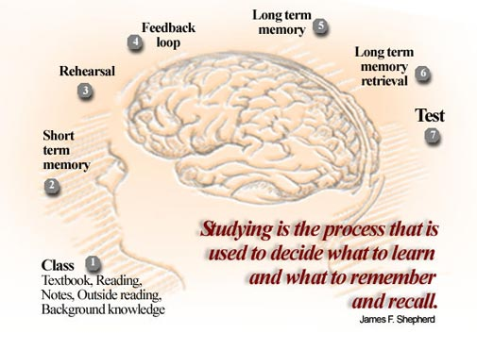
Study Skills Tools (including Electronic Flashcard apps)
Headmagnet –  http://headmagnet.com/ | Headmagnet creates a model of what's going on in your head.  It predicts what memories have faded away, and what memories are still inside, allowing you to quickly get things in your head and keep them there.  The more you use headmagnet, the better it gets at modeling what goes on in your head.
StudyBlue Online Flash Cards  http://www.studyblue.com/online-flashcards  Study Blue App  https://itunes.apple.com/ie/app/studyblue/id323887414 | Flashcard app includes audio, text and graphics support. Requires a free studyblue.com account - well worth it.
Quizlet  http://quizlet.com/  Quizlet Mobile  http://quizlet.com/mobile | "largest flash cards and study games website"
StudyHive  http://www.studyhive.com/ | Create your own study cards or search the public decks. You will need to download Siverlight to use the site online (the link is available at the site). Syncs with Flashcards Pro app (free) for the iPod Touch, iPhone or iPad which allows you to study anytime.
Study Shack  http://www.studystack.com/ | Create interactive web-based flashcards or use ones that are already created; if you use stacks that are already created, check them first as there are errors in several of the created stacks.
Flashcard Machine  http://www.flashcardmachine.com/ | Allows the user to create interactive web-based study flash cards.
Cramberry  http://www.cram.com/ | Clean and simple online interactive flash card tool. If you are looking for simplicity, this will work for you. No bells or whistles; just a simple user interface. (a $ 3.99 iTunes app is also available).
RecallPlus  http://recallplus.com/index.php | Students can organize their notes, create flashcards, make use of 3D tools and more in this great mind mapping tool. It is downloadable.
MyMentor  http://mymentor.ru/ | Create, share and study flashcards online; download flashcards in printable format.
WordStash  http://flashcardstash.com/ | Half flashcard, half dictionary, and full awesome!
How to Write and How to Study - by Subject
Need to know how to study math? Write a chemistry lab report? Or how to pass a psychology final? All the study strategies and writing techniques are organized here by subject matter (29 subjects).

http://www.howtostudy.org/resources.php

Other Online Study Tools
http://www.examtime.com/notes-software/
http://www.studygs.net/
http://www.dropmind.com/
http://pocketmod.com/
http://www.funnelbrain.com/
http://www.glencoe.com/sec/math/studytools/index.php4

